Rafał Pietrasina
He heads the management board of Anwim S.A and is a member of the management board of ESPPOL Trade S.A.

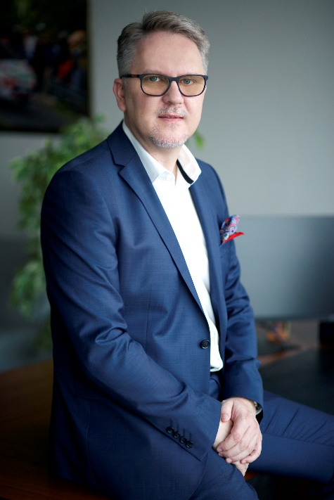
Rafał Pietrasina has been working in the fuel industry since 1997, when he became the manager of Esppol's branch in the Silesia region of Poland. In 2001, he was promoted to vice-president of Esppol's management board and became the company's president in 2004. In 2013, he took charge of the management board of Anwim S.A. and paved the way for the two companies to merge a year later.
Before joining Anwim, he had worked in the metallurgical industry.
He has a degree in metallurgy from Kraków's AGH University of Science and Technology.

Areas of expertise (suggested areas for interviews)
- expansion plans for Anwim S.A / the Anwim Group,
- a strategy for expanding the MOYA chain of filling stations,
- the situation in Poland's fuel market,
- corporate social responsibility (CSR).

