Paweł Grzywaczewski
He is a member of the management board of Anwim S.A. and its director of sales.

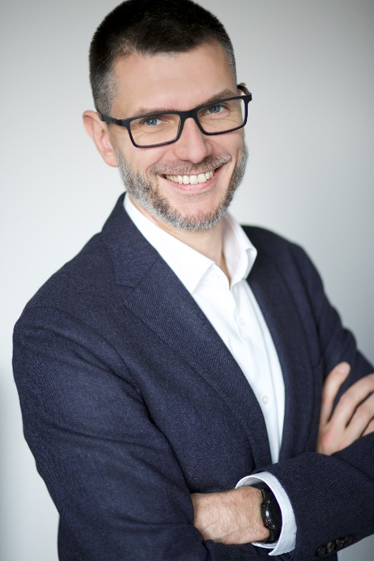
Paweł Grzywaczewski is the brains behind the MOYA filling station brand, which he has been expanding gradually since 2009, with the support of his team. On a daily basis, he is responsible for setting the direction for the expansion of the MOYA network and oversees all the teams that work to make the brand stronger.
He joined Anwim S.A in 1999, initially as a sales representative and then a sales coordinator. He has been a member of Anwin S.A.'s management board since 2002. Until 2014, he was also a member of the management board of Esppol S.A., Anwim's sister company. He had previously worked as a sales representative at Neste Oil and Sedona S.C.
Paweł Grzywaczewski has a master-level degree in marketing and management from SGH Warsaw School of Economics and a postgraduate diploma from Kozminski University.
Areas of expertise (suggested areas for interviews)
- expansion plans for the MOYA chain development plans for both Anwim's own filling stations and those operated by franchisees,
- the Polish filling station sector,
- the chain strategy: boosting the market share of the chain,
- the market conditions of operating a chain of filling stations,
- solutions for fleets,
- the transport market,
- new fuels.

