Andrzej Kondys
Member of the Management Board of Anwim S.A., Director of MOYA Operations

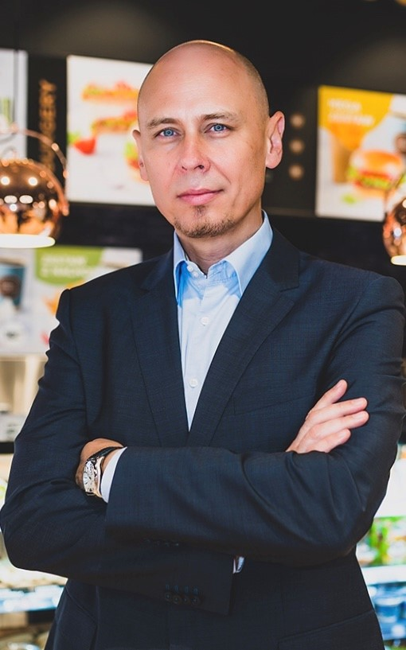
Andrzej Kondys has considerable experience of working in the FCMG industry, which he gained as a manager for Jeronimo Martins for many years. During the thirteen years with the owner of the Biedronka store chain and the Hebe chemist store chain, he climbed up the career ladder from traineeship to the position of director of operations.
In 2013, he joined Statoil Fuel and Retail (renamed as Circle K Polska sp. z o.o.), a fuel company, where he was a member of the company's management with a responsibility for the convenience, marketing and communications areas. He has also been the vice-president of MOL, the multinational fuel company. Andrzej Kondys has considerable experience of working in an international environment. He speaks English and Portuguese fluently.
Areas of expertise (suggested areas for interviews)
- customer experience,
- MOYA network development plans for both Anwim's own filling stations and those operated by franchisees,
- the chain strategy: boosting the market share of the chain,
- Anwim's investment in land for new filling stations,
- the market conditions of operating a chain of filling stations,
- developing the company's range of products other than fuels: retail stores and food service operations,
- the company's marketing strategy,
- strategies for implementing eco-friendly solutions at filling stations

